Deploy an application through the EKS cluster.

Here we take a sample docker image in the docker sample registry.

In this case, we take a sample voting image on the docker sample registry.

First, create an EKS cluster.

Command: - eksctl create cluster --name democtl --nodegroup-name democtlng --node-type t2.micro --nodes 8 --managed

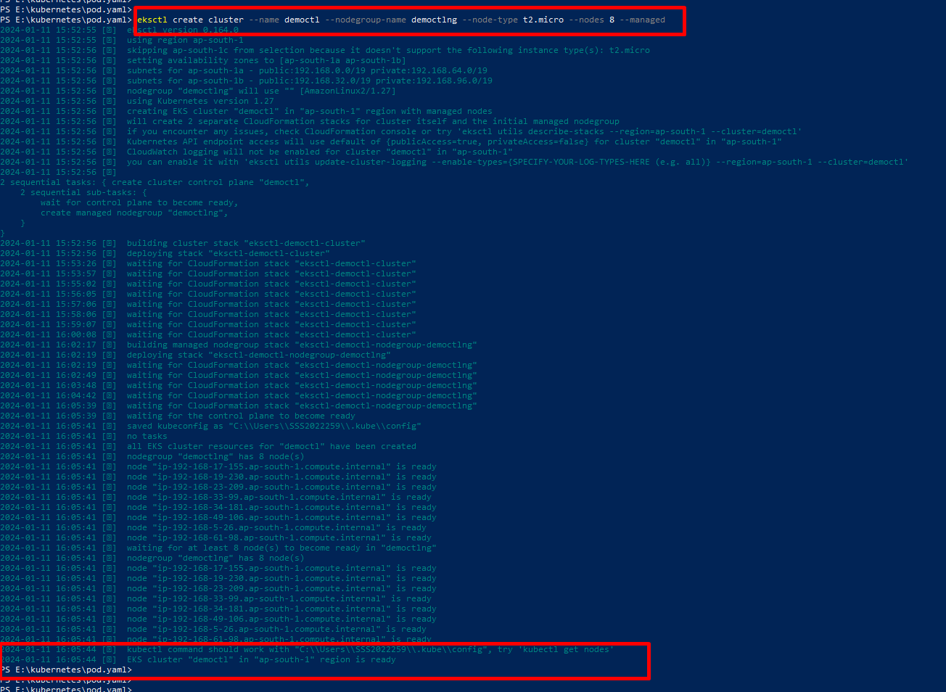

Now, create a yaml files for creating pods and services.

All files must be in same path

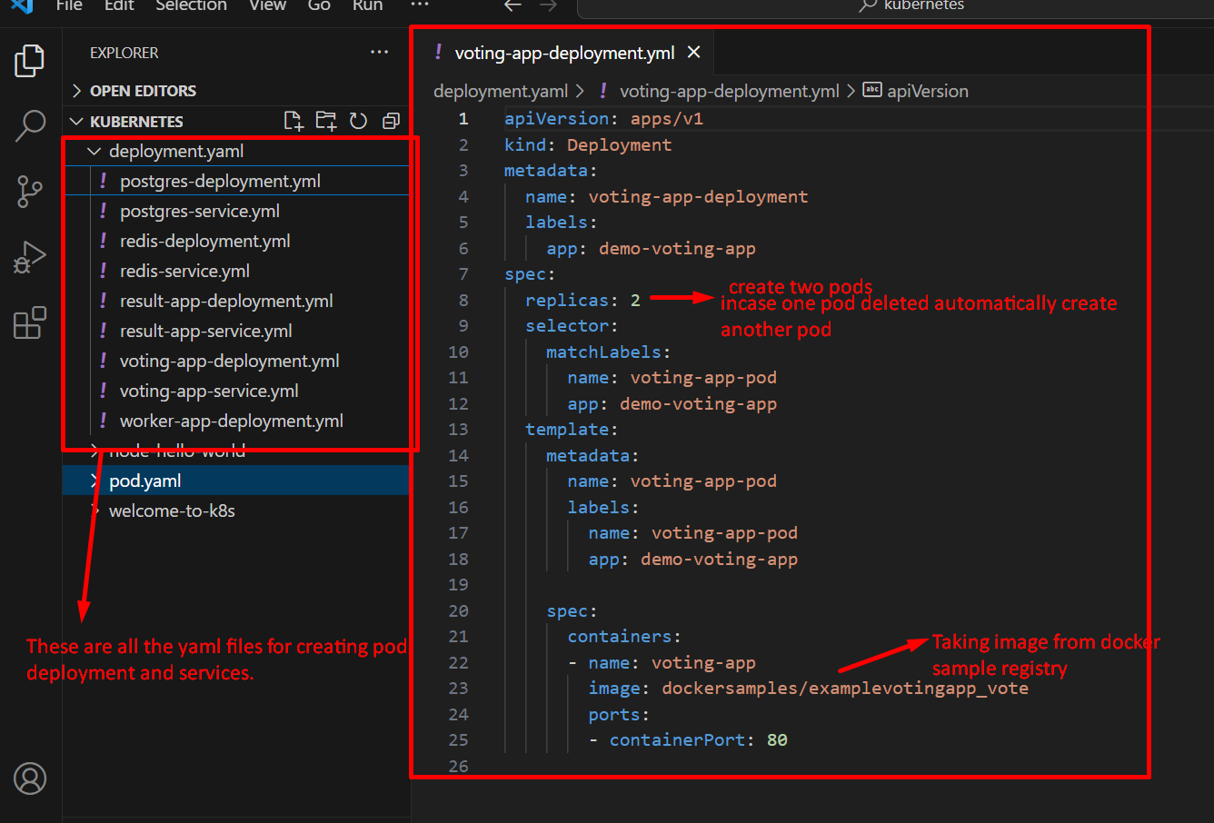

First, we set the correct directory.

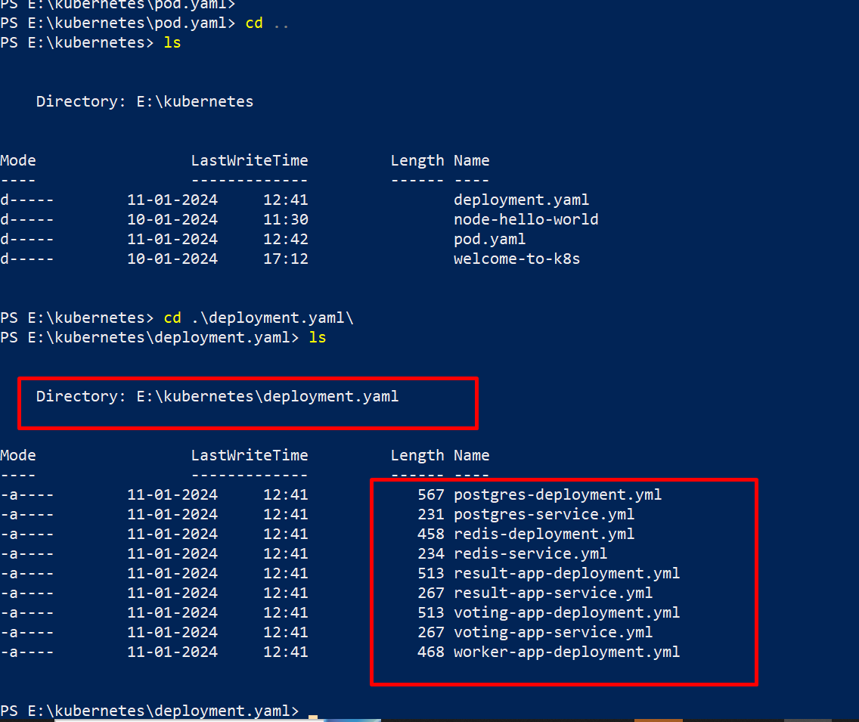

Now we apply all files.

Commands: - kubectl apply -f .\voting-app-deployment.yml

kubectl apply -f .\voting-app-service.yml

kubectl apply -f .\redis-deployment.yml

kubectl apply -f .\redis-service.yml

kubectl apply -f .\worker-app-deployment.yml

kubectl apply -f .\postgres-deployment.yml

kubectl apply -f .\postgres-service.yml

kubectl apply -f .\result-app-deployment.yml

kubectl apply -f .\result-app-service.yml

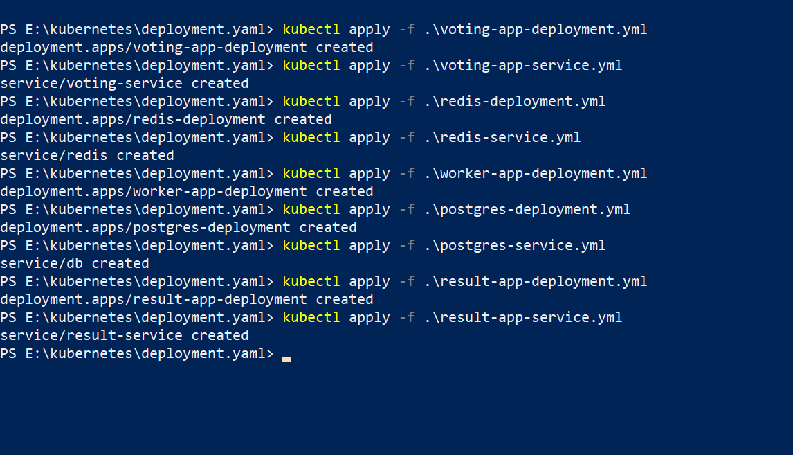

We successfully created deployment pods and services.

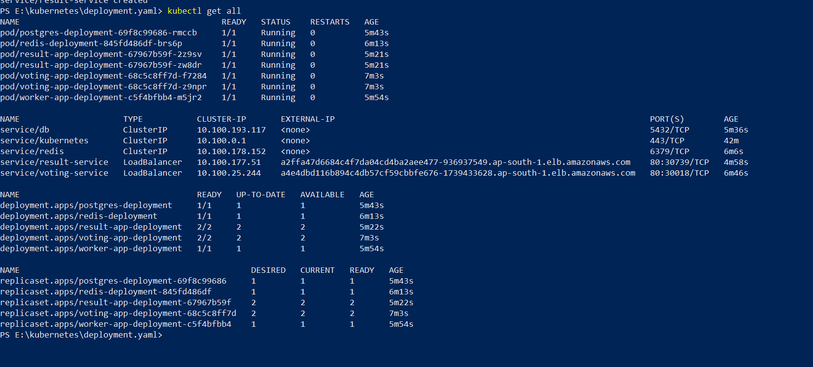

We copy the load balancer DNS name URL.

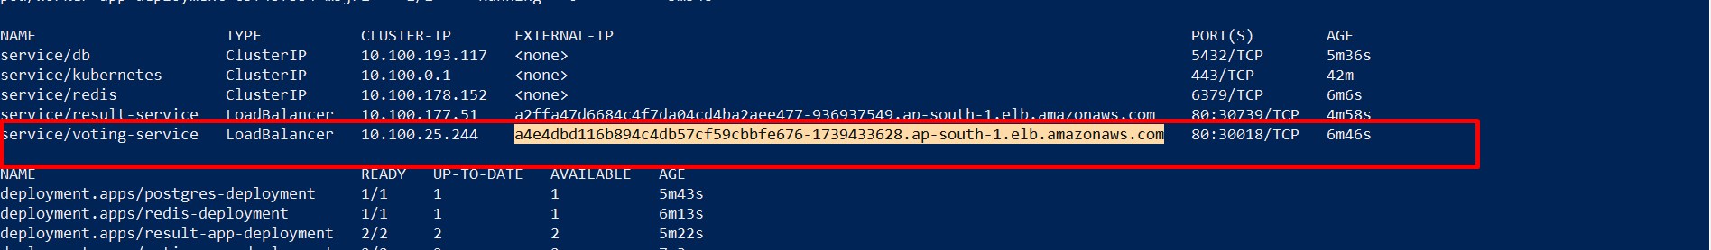

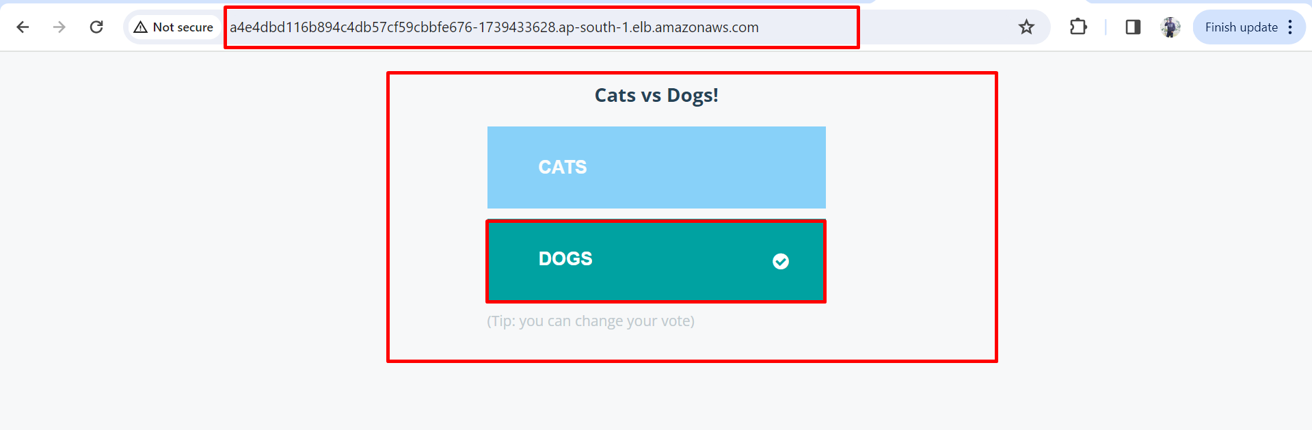

Now check result

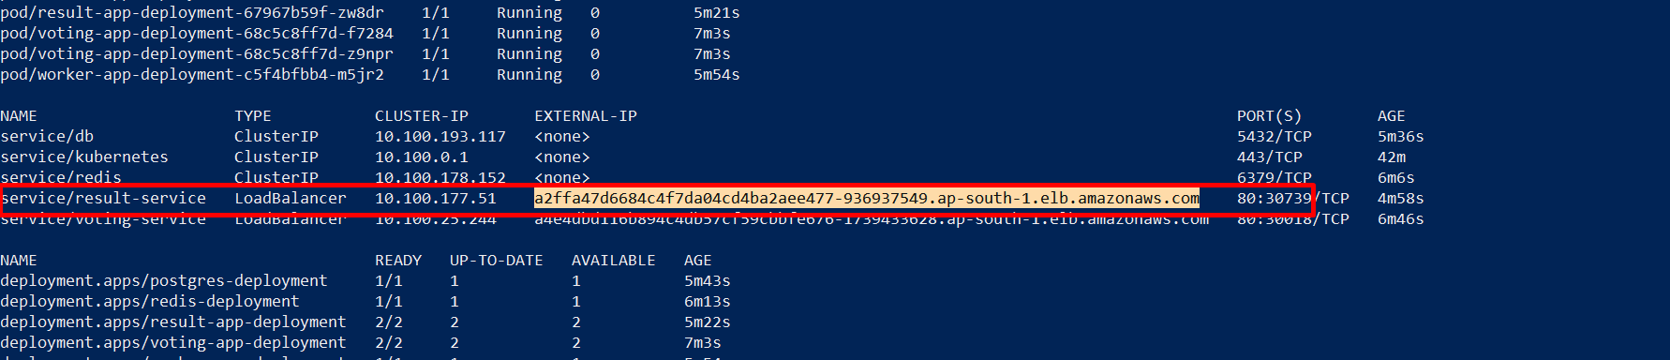

We copy that result LB DNS URL and paste in google.

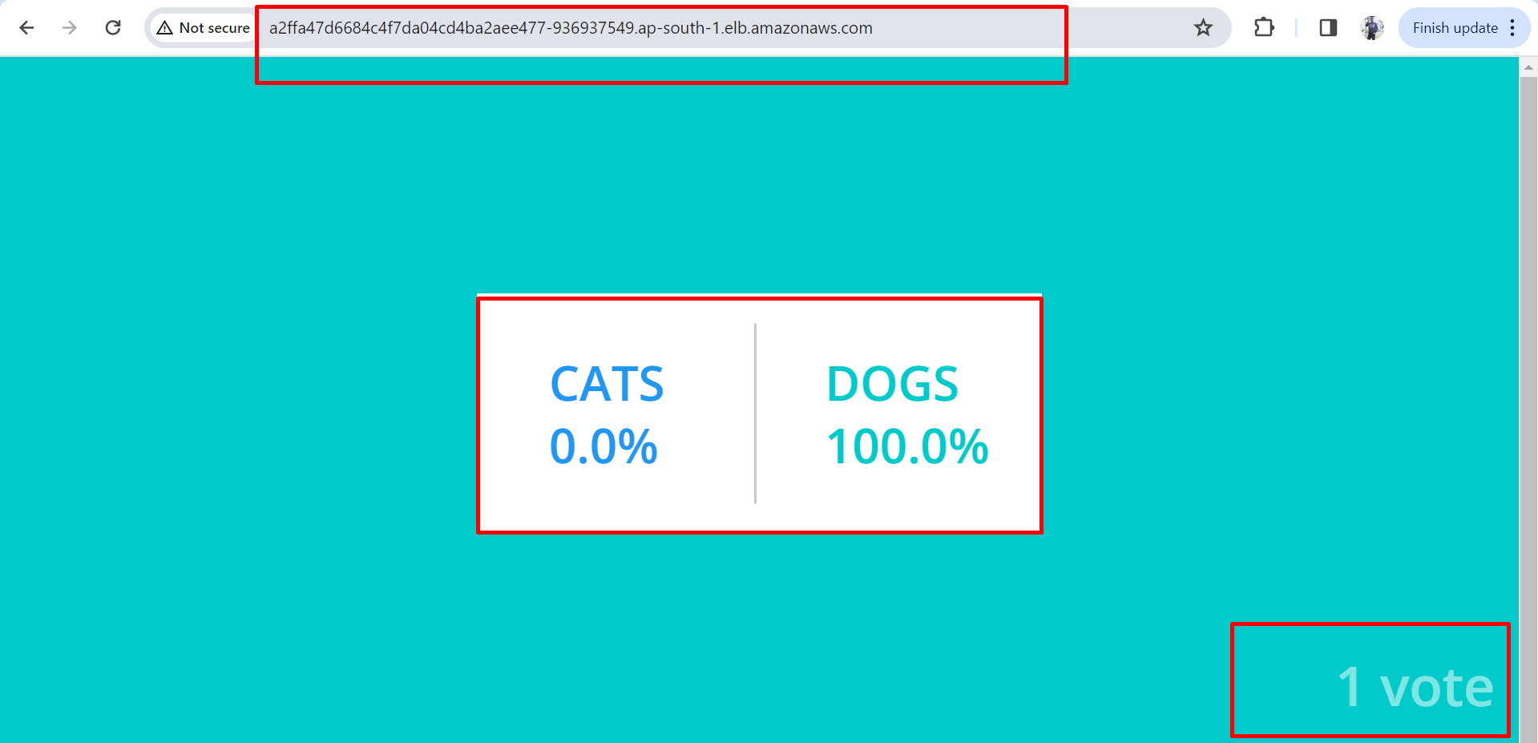

Now I send voting link to my frds.

